

Prescribing of Mounjaro® (Tirzepatide) for Obesity for NHS Primary Care Patients
Information Leaflet for Patients registered with a Bridgwater GP Practice

Bridgwater Bay Primary Care Network (PCN) works with the following 9 GP surgeries in and around Bridgwater:
- Cannington, Cranleigh Gardens, East Quay,
- North Petherton, Polden, Quantock,
- Redgate, Somerset Bridge and
- Taunton Road Medical Practices

Am I eligible to be prescribed Mounjaro® on the NHS?
From 23 June 2025 NHS patients will be eligible for tirzepatide (Mounjaro®) for the management of obesity, where a clinician considers it an appropriate treatment and ONLY if they have four or more of the following weight related health problems, as well as a BMI of 40 and over:
- Type 2 diabetes
- High blood pressure
- Cardiovascular disease
- Obstructive sleep apnoea
- High cholesterol
If I am eligible what do I need to consider and what support will I get?
Tirzepatide (Mounjaro®) might not be considered clinically suitable for everyone and not everyone who meets the very tight eligibility criteria will want to use drug therapy to support their weight loss.
Patients fulfilling the above criteria will be at very high risk for poor cardiovascular outcomes so having clinical oversight and support in place is an essential component for accessing (Mounjaro®) for the management of obesity on the NHS. Those accessing the drug will also be required to participate in a structured wraparound care support package focused on good nutrition for health and for increasing physical activity. This support is designed to help people get the most out of their treatment and enhance their ability to achieve and maintain healthy weight loss.
Patient centred discussions and optimisation of medication for their 4 identified co-morbidities also takes place (blood pressure treatment, statins for CVD risk etc) alongside discussion of access to and risks/benefits of tirzepatide for Obesity.
How quickly, if I am eligible will I be prescribed Mounjaro®?
Somerset’s Integrated Care Board will be providing more detailed advice as to how Mounjaro® can be prescribed to the eligible cohort so prescribing may not be immediate however initial discussions can take place with a Diabetic Nurse if you meet the criteria above.
Can I access alternative weight loss programmes to Mounjaro®?
If you are eligible but unsure whether Mounjaro® is for you or you are not currently eligible, there are other options available on the NHS, including weight loss programmes which use tried and tested methods such as lifestyle changes and nutrition and physical activity advice.
Following are some links which you might find helpful:
- For support to manage your weight: https://www.sasp.co.uk/weight-management
- To check your BMI, understand food portion sizes and join weight management programmes:
https://healthysomerset.co.uk/healthy-body-and-mind/healthy-weight/Healthy weight
I have diabetes, are there any other weight management programmes available?
The NHS Digital Weight Management Programme could help you if you are living with obesity and also have diabetes, high blood pressure, or both. If this is you, you could benefit from this 12-week programme. It’s free and easily available via a smartphone, tablet, or computer.
You can learn more about the programme here NHS England » How to access the programme
Where can I get support for weight loss and healthy eating?
You may find the following links useful:
- Understanding Whole Foods and Healthier Eating
- Understanding Metabolic Health
- Low Carb Project
- Moving towards more whole foods
Is there support to help me with my goals around weight management?
You may find booking an appointment with the Health Coach who works from your GP Practice or the Health and Wellbeing Hub at Victoria Park beneficial. The coach will help you set goals and provide you with support to achieve them. You can call your GP Practice to book an appointment or self referral using the following link: Forms - Somerset Activity & Sports Partnership
If I am receiving Mounjaro® treatment privately can I switch to NHS provision?
If you have accessed Mounjaro® privately and you meet the criteria of having at least four of the following related health conditions as well as a current BMI of 40 and over:
- Type 2 diabetes
- High blood pressure
- Cardiovascular disease
- Obstructive sleep apnoea
- High cholesterol
You may be eligible to access NHS prescribing ONLY if you consent to and are referred into the Somerset structured wraparound support service.
If I am receiving Mounjaro® treatment privately and my BMI is now below 40 can I switch to NHS provision?
Even if you meet at least of the four criteria if your BMI is now below 40 NHS prescribing cannot be retrospectively applied if ALL the current criteria is not met.
If your BMI is now below 40 they would not be eligible to move to NHS provided treatment.

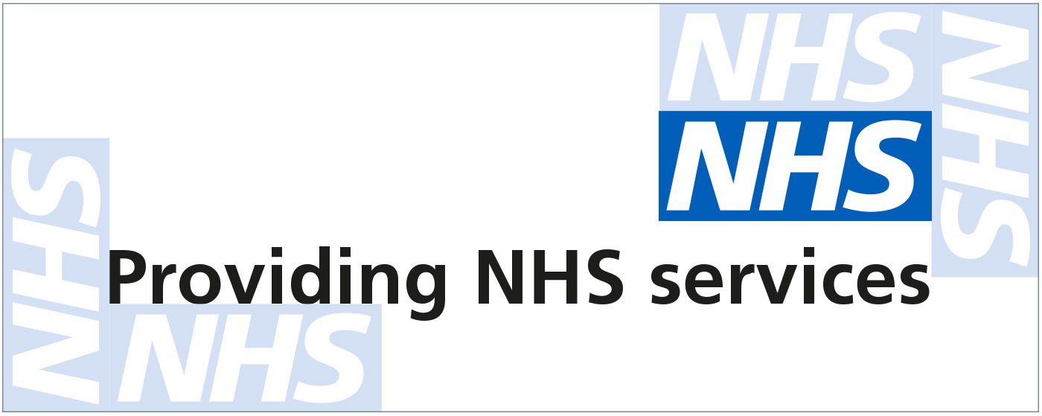

Revised June 2025

